Capitalize Words in Paper Title

FIRST AUTHOR
University Name, Address, City, Country, Email for corresponding author
SECOND AUTHOR
Company Name, Address, City, Country
If you are submitting a full paper, insert your abstract here. If you are submitting an abstract, then delete this section and write your abstract to the Introduction section. Abstract (written here) should include only one paragraph giving a clear summary of the article below. The length of the abstract should not exceed 2000 characters including spaces.

This is the Introduction Section
This document is a template for Microsoft Word. Do not change the font type, font sizes, line spacing or other formatting. Use italics to emphasize; do not underline. It is preferable to use main section numbering. Each paragraph should be indented as in this example. Use Format Painter tool to format your paragraphs when necessary.
Submit your paper in PDF format. This is the second paragraph of the section. This is the second paragraph of the section. This is the second paragraph of the section. This is the second paragraph of the section.

The Second Section
Format your images and pictures using a suitable graphics program. Use only grayscale figures preferably with 300 dpi resolution. Refer to your figures as Fig. 1.
This is the second paragraph of the section. This is the second paragraph of the section. This is the second paragraph of the section. This is the second paragraph of the section.
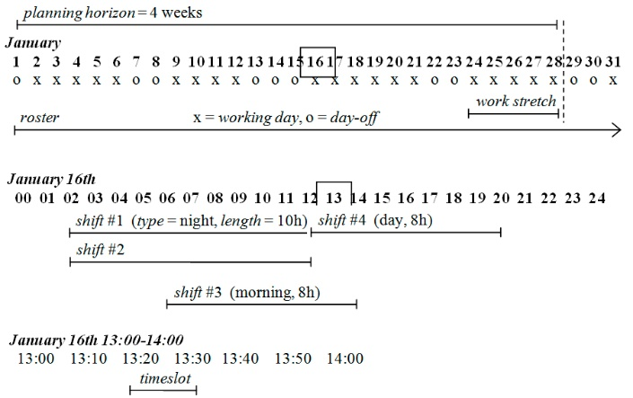
Fig. 1. Explain the significance of the figure in this caption below the figure. Keep the length of the caption short.
Do not center the figure. Insert 24p around the figure as in this example. You can break the line using Shift-Enter
as in this example. Note the abbreviation Fig. 1. Followed by two spaces.
This is the third paragraph of the section. This is the third paragraph of the section. This is the third paragraph of the section. This is the third paragraph of the section.

The Third Section
Tables are numbered with Roman numerals. Refer to your tables as Table I. Use vertical lines to make the table more readable. Do not use horizontal lines.
Number citations consecutively in square brackets [1]. Multiple references are each numbered with separate [2], [3] brackets [4]-[5]. The references at the end of this template are given in the preferred format.
TABLE I
Keep the length of the caption short. Do not center the figure. Insert 24p around the figure as in this example.
Col 1 | Col 2 | Col 3 | Col 4
Text 1 | 11 | Some text that wraps to the second line | 20 (21)
Text 2 | 22 | Some text that wraps to the second line | 30 (44)
Text 3 | 33 | Some text | 50 (99)
Text 4 | 44 | Some text | 70 (77)
This is the third paragraph of the section. This is the third paragraph of the section. This is the third paragraph of the section. This is the third paragraph of the section.

References
- M.R. Garey and D.S. Johnson, “Computers and Intractability: A Guide to the Theory of NP-Completeness,” Freeman, 1979.
- J. Tien and A. Kamiyama, “On Manpower Scheduling Algorithms,” in SIAM Rev. 24 (3), pp. 275–287, 1982.
- H.C. Lau, “On the Complexity of Manpower Shift Scheduling,” Computers and Operations Research 23(1), pp. 93-102, 1996.
- K. Nurmi, J. Kyngäs and A.I. Järvelä, “Ten-year Evolution and the Experiments in Scheduling a Major Ice Hockey League”, in Daniel Hak (ed.): An in Depth Guide to Sports, pp 169-207, Nova Science Publishers, USA, 2018.

